**Annexure A : List of Equipment in Hematology and amphibian Laboratory**

|  |  |
| --- | --- |
| **Sr No** | **Name of the Equipment** |
| 1 | Microscopes ( binoculars), oil immersion |
| 2 | Demonstration eye piece |
| 3 | Double demonstration eye piece |
| 4 | Stage incubator |
| 5 | Westergreen's pipette for E.S.R. on stand |
| 6 | Wintrobe’s pipette for ESR and PCV with stand |
| 7 | Hemoglobinometer Sahli's/Hellige |
| 8 | Hemocytometer |
| 9 | Glassware |

**Annexure B**

**List of Equipment in**

**Clinical Physiology Laboratory**

|  |  |
| --- | --- |
| **Sr No** | **Name of the Equipment** |
| 1 | Tuning fork time marker 100/sec |
| 2 | Electrodes |
| 3 | Marey's tambour |
| 4 | Perimeter Pristely Smith S/LP.984 B & T |
| 5 | Sphygmomanometer (digital and mercury) |
| 6 | Stethoscopes |
| 7 | Stethoscopes, demonstration with multiple ear pieces |
| 8 | Polygraphs |
| 9 | Venous pressure apparatus |
| 10 | Spirometer, ordinary |
| 11 | Gas analysis apparatus, Halden's student type |
| 12 | Van Slyke's apparatus manometric |
| 13 | Sherrington Starling kymograph (electrically driven) |
| 14 | Gas analyser automatic for CO2, O2, N2 |
| 15 | Low voltage unit for tapping 2 and 4 volts for stimulation |
| 16 | Electromagnetic time marker |
| 17 | Douglas bag, complete |
| 18 | Basal metabolism apparatus |
| 19 | Mosso's Ergograph with metronome |
| 20 | Clinical thermometer |
| 21 | Compass aesthesiometer |
| 21 | Thermo-aesthesiometer |
| **Sr No** | **Name of the Equipment** |
| 22 | Algometer |
| 23 | Apparatus for passive movement |
| 24 | Knee hammer |
| 25 | Stethograph |
| 26 | Bicycle Ergometer |
| 27 | Olfactometer |
| 28 | Ophthalmoscope |
| 29 | Schematic eye |
| 30 | Phakoscope |
| 31 | Perimeter with charts (Lister’s) |
| 32 | Color perception lantern Edridge green |
| 33 | Maddox rod |
| 34 | Newtons color wheel |
| 35 | Ishihara Chart |
| 36 | Snellen chart |
| 37 | Jaeger's chart |
| 38 | Tuning fork to test hearing 32-10000 cps(sets-100, 256, 512 Hz) |
| 39 | Dynamometer |
| 40 | Otoscope |
| 41 | Stop watch |
| 42 | Multi-channel Physiograph, 3 channels, complete with accessories |
| 43 | Student physiograph, (single channel) with accessories |
| 44 | Centrifuge, high speed with technometer |
| 45 | Colorimeter, photoelectric |
| 46 | Myograph stand |
| **Sr No** | **Name of the Equipment** |
| 47 | pH meter electric |
| 48 | Electronic stimulator |
| 49 | Thermometers, balances, microslides and glassware |
| 50 | Digital Physiograph |
| 51 | ECG Machine |
| 52 | Harvard step stool ( 20 inch and 16 inch) |
| 53 | Digital weighing scale |
| 54 | Measuring tape |
| 55 | Models and Charts |
| 56 | Refrigerator |
| 57 | Video Simulator for amphibian and mammalian experiments ( computer assisted) |
| 58 | Peak flow meter |
| 59 | Spirit lamps |

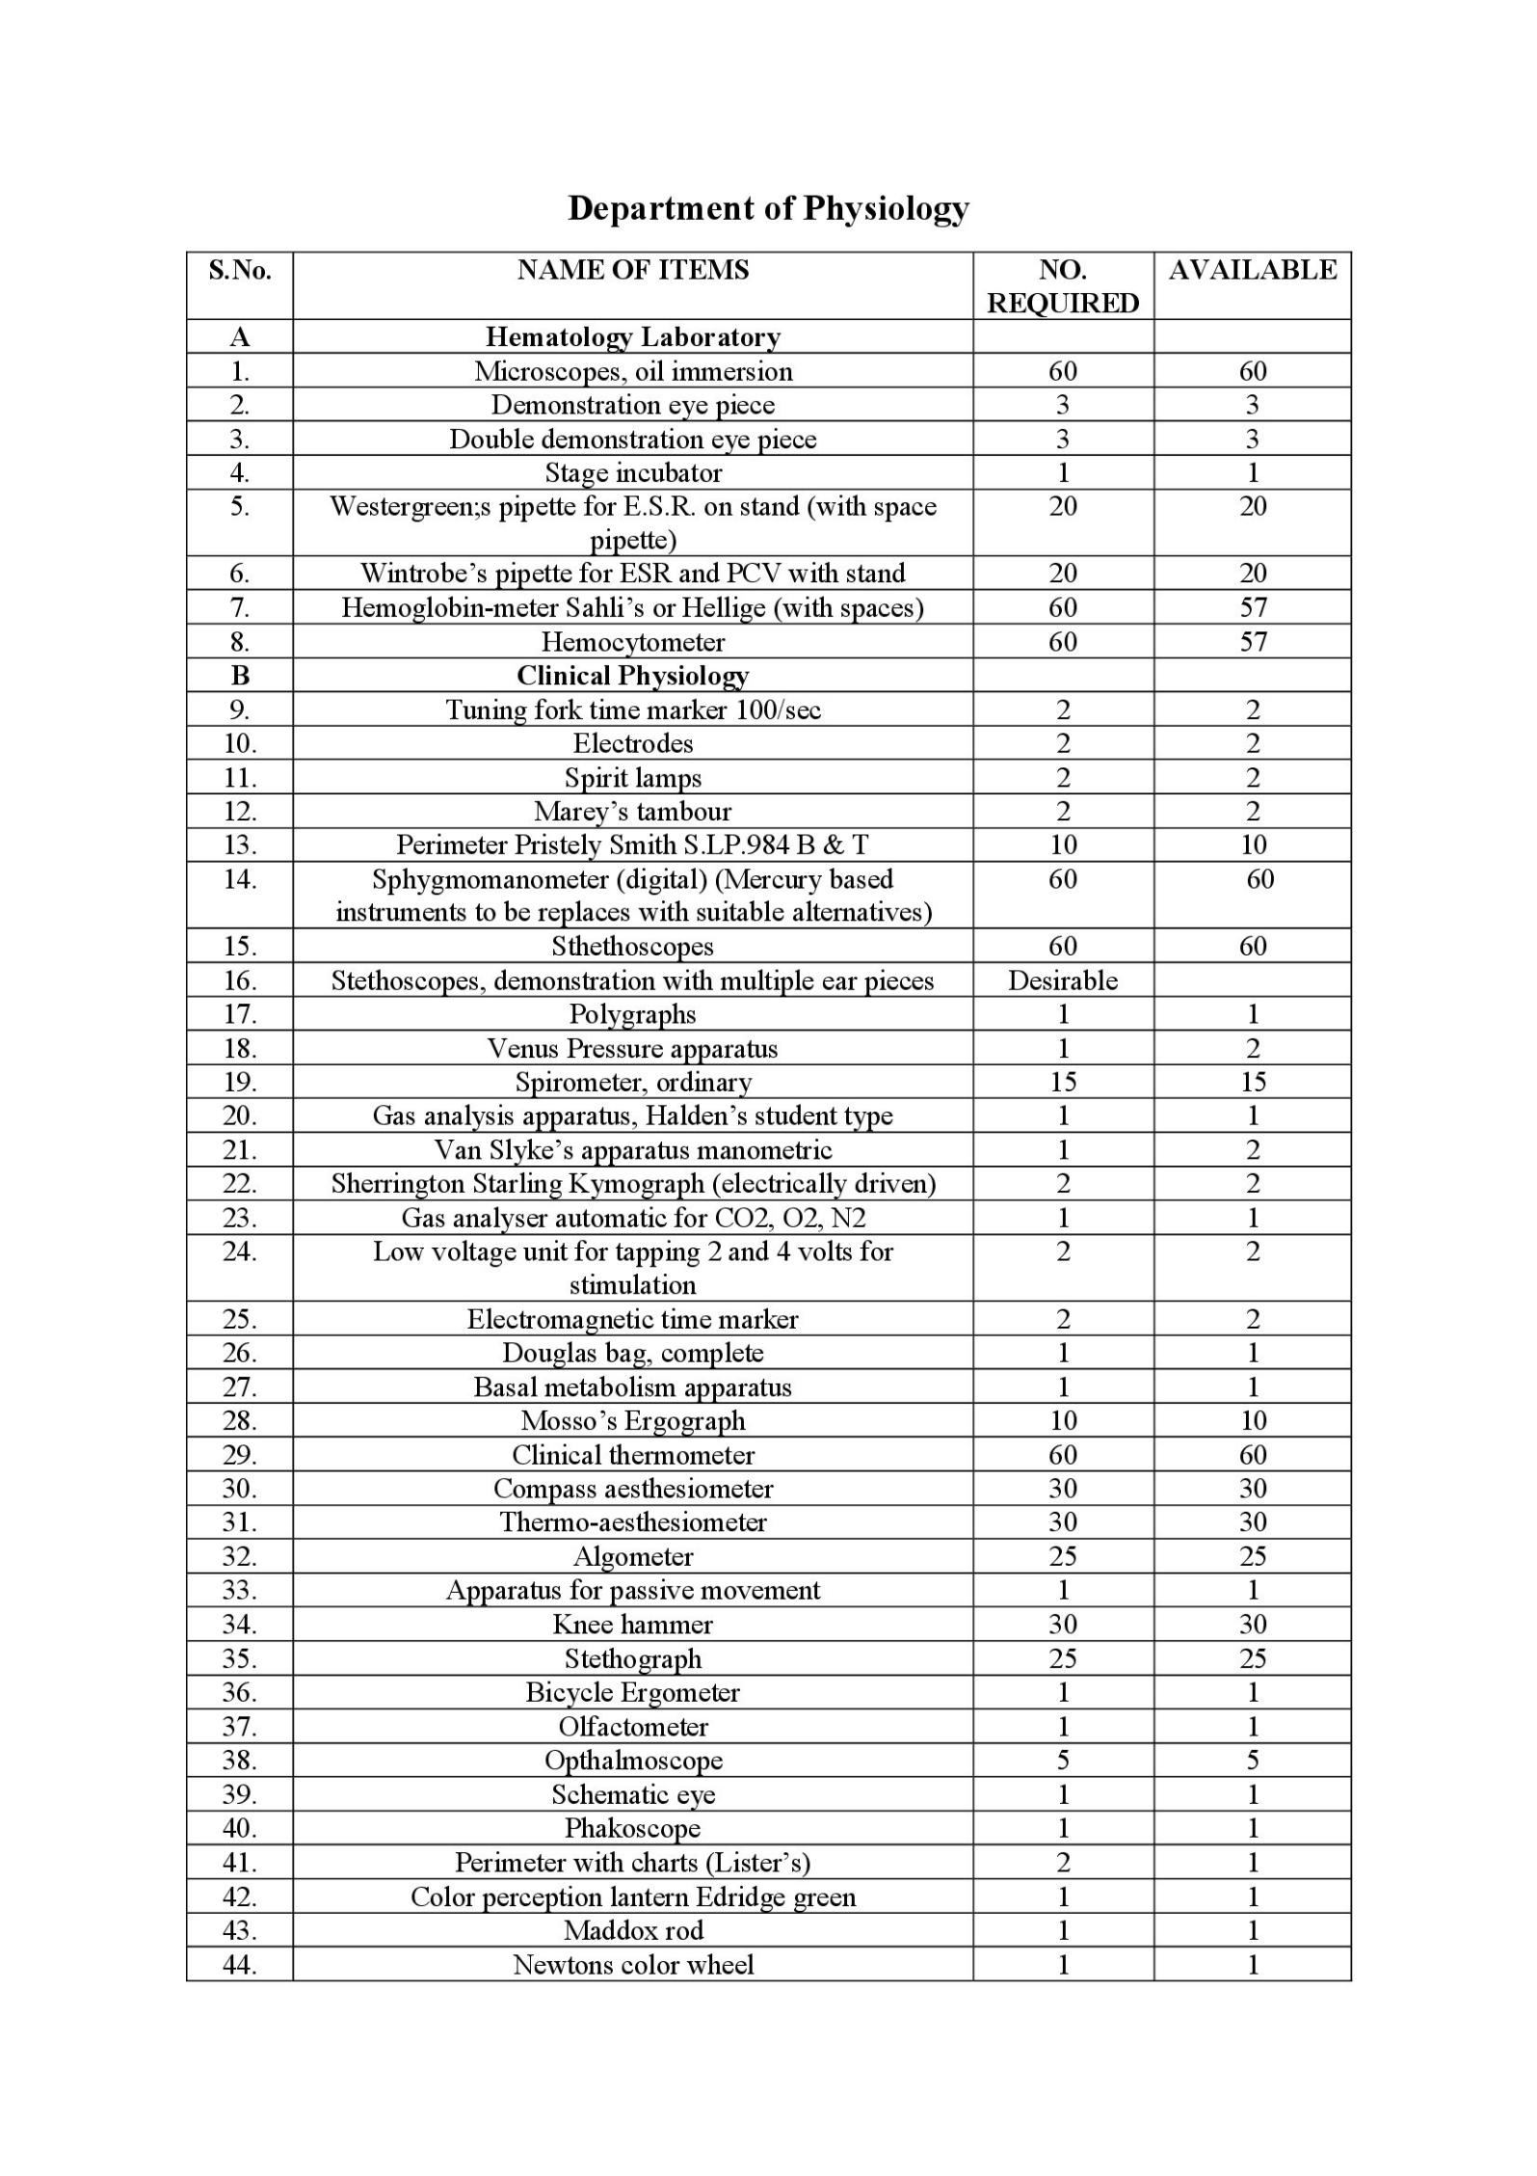

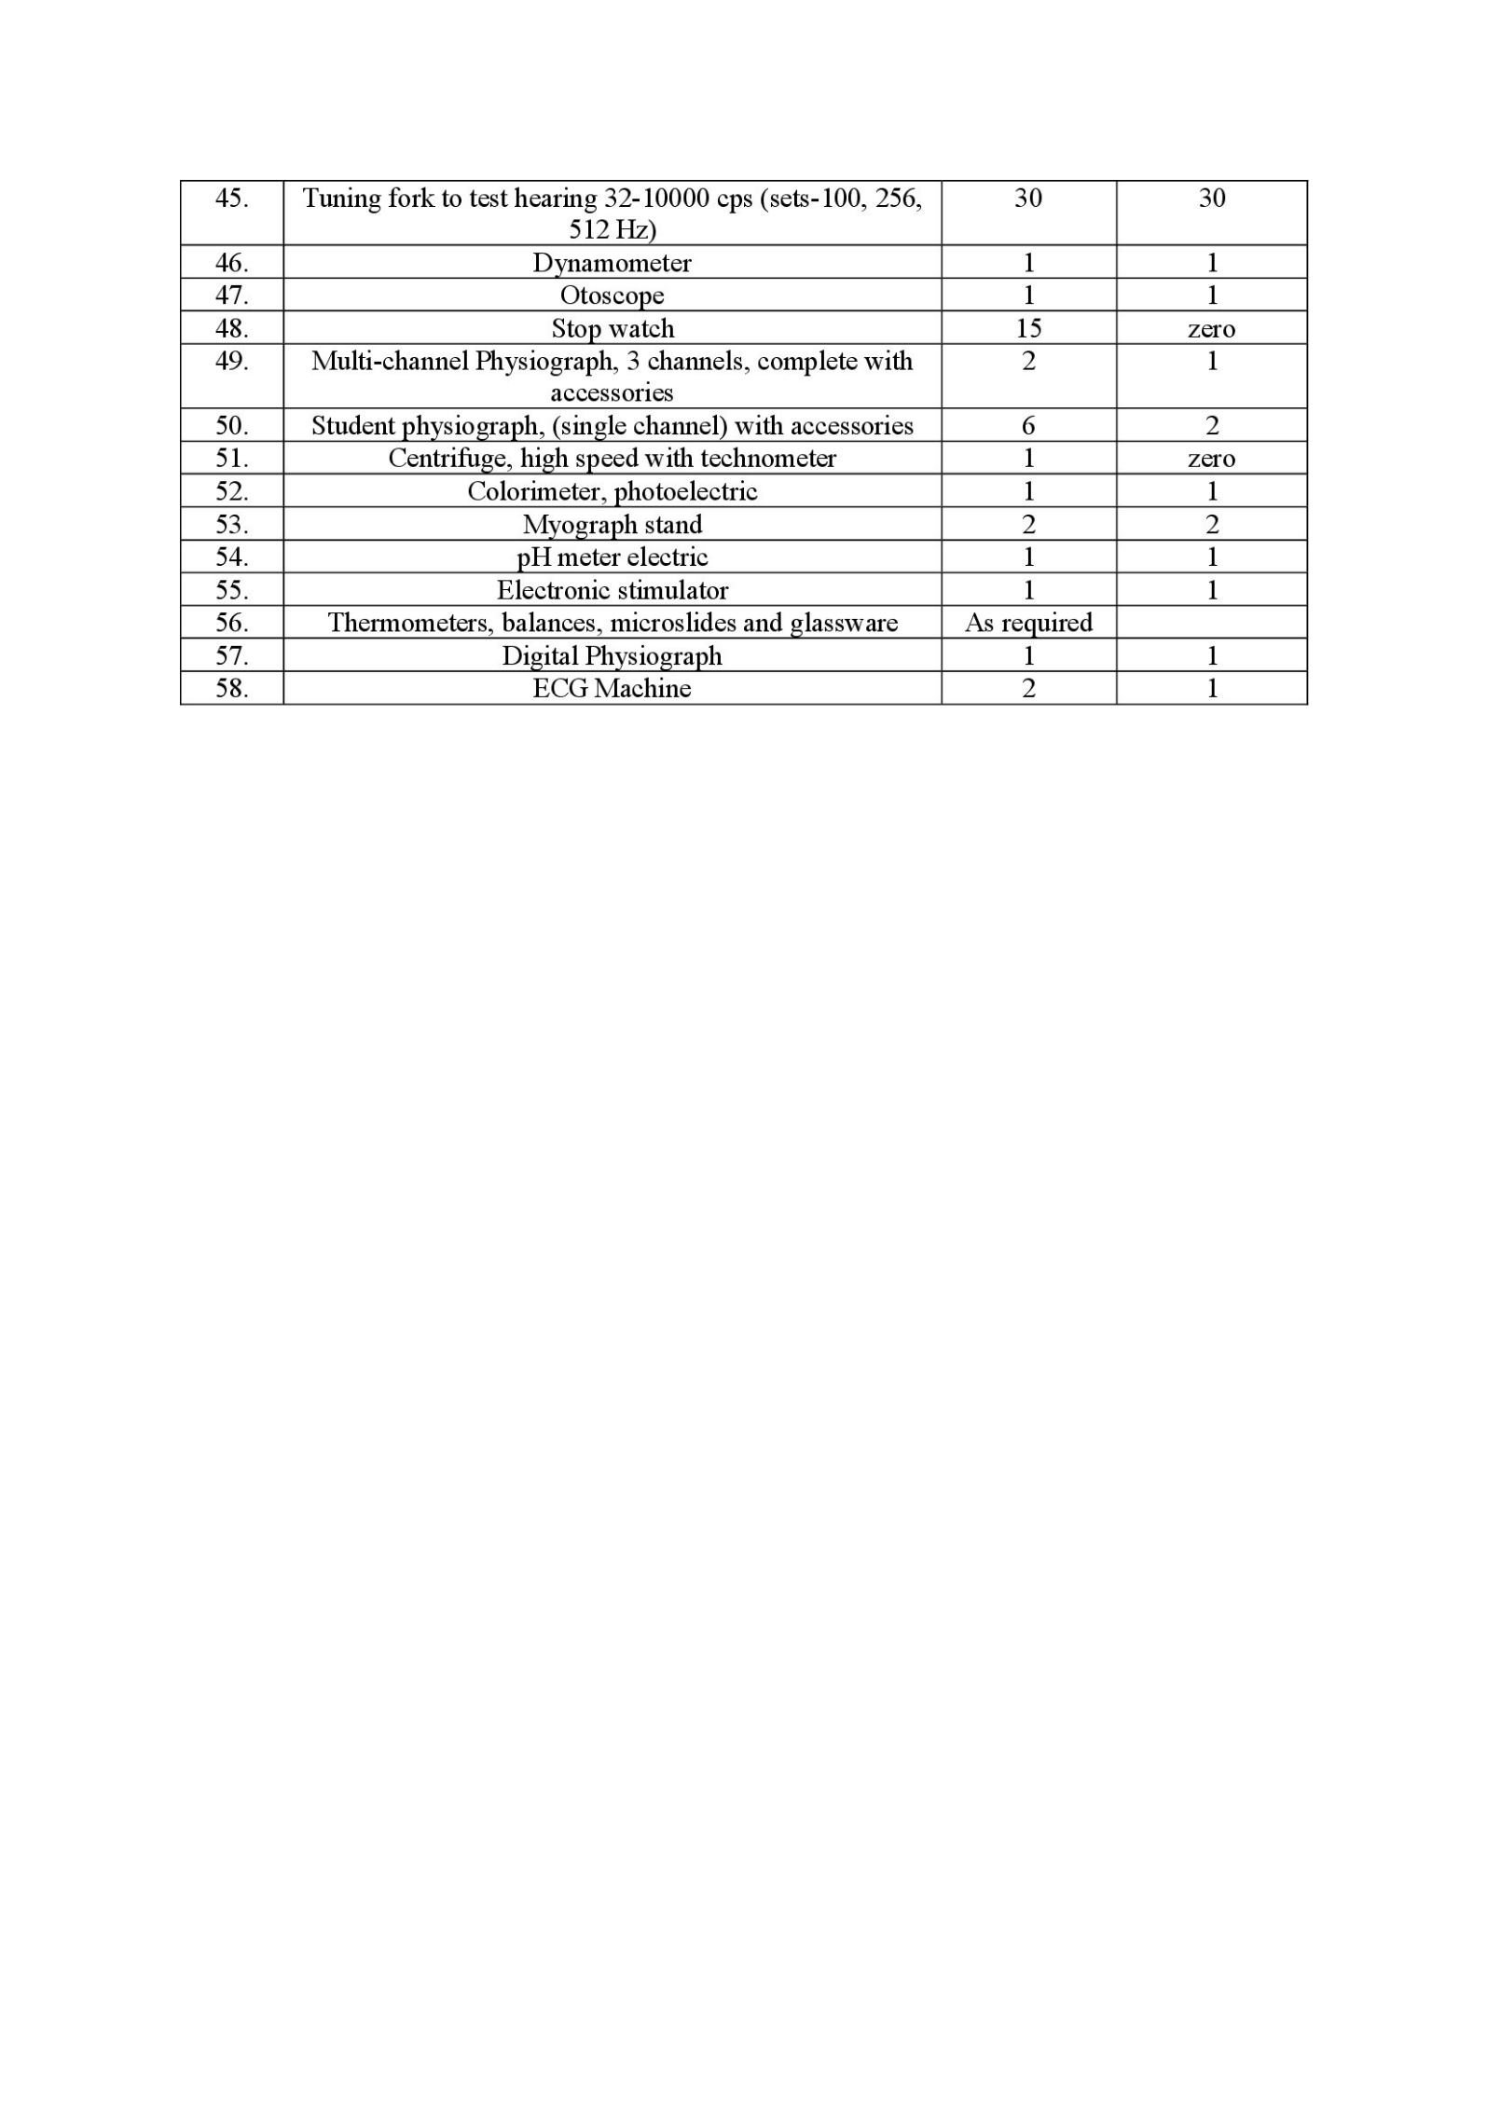

**Annexure C :PUBLICATION of department faculties**

**Department of Physiology**

**A ]Dr Janardan Bhatt Prof and Head**

Name Publication in Vancouver referencing style.

**1 A HUMAN CONSCIOUSNESS: facts, fiction and medical perspectives**

Dr Janardan V Bhatt

IJABMS July 2023Doi:DOI: 10.5281/zenodo.8229745

Volume 25B 41 No

**2 LIFE, RACE AGAINST DEATH**

Dr Janardan Bhatt

Indian journal of applied basic medical sciences January 2023

Volume 25A 40 no

**3 Carbon dioxide level in the Breath of smokers and non smokers , a comparative study**

Sheela Chaudhary, Janardan Bhatt,Manisha Makwana , Surbhi Ranga ...[eISSN 2249-7935]Vol.26 B(43) July-2024.

4 **Manisha Makwana. Impact of Humidity on heavy duty workers compared to non-heavy duty workers a study on peak expiratory flow rate**

Surbhi Ranga, Veenodini Warhade , Janardan Bhatt, Sheela Chaudhary, .[eISSN 2249-7935]Vol.26 B(43) July-2024.

**B] Dr Parth Nayak :Asso prof of Physiology ,**

**1 Key hypertension breakthroughs and emerging trends from the AHA's scientific sessions**

[Current Problems in Cardiology](https://www.sciencedirect.com/journal/current-problems-in-cardiology)

[Volume 49, Issue 4](https://www.sciencedirect.com/journal/current-problems-in-cardiology/vol/49/issue/4), April 2024, 102434

**PUBMED**

Author links open overlay panelSashwath Srikanth MBBS, MD a, Avilash Mondal MBBS, MD b, Sanjana Aggarwal MBBS c, Naga Ruthvika Alle MBBS d, Olufemi Odugbemi MD e, Parth R Nayak MD f, Ankit Vyas MD g, Rupak Desai MBBS h

Cite [**https://doi.org/10.1016/j.cpcardiol.2024.102434**](https://doi.org/10.1016/j.cpcardiol.2024.102434)[**Get rights and content**](https://s100.copyright.com/AppDispatchServlet?publisherName=ELS&contentID=S0146280624000732&orderBeanReset=true)

**2 In-hospital outcomes of percutaneous left ventricular assist device recipients in cardiogenic shock hospitalizations with chronic kidney disease: A nationwide analysis**

**Curr Problems in Cardiology**

**Metanalysis**

**PUBMED**. 2025 Jan 17;50(3):102993.

 doi: 10.1016/j.cpcardiol.2025.102993. Online ahead of print.

[Akhil Jain](https://pubmed.ncbi.nlm.nih.gov/?term=Jain+A&cauthor_id=39828105)[1](https://pubmed.ncbi.nlm.nih.gov/39828105/#full-view-affiliation-1), [Karnav Modi](https://pubmed.ncbi.nlm.nih.gov/?term=Modi+K&cauthor_id=39828105)[2](https://pubmed.ncbi.nlm.nih.gov/39828105/#full-view-affiliation-2), [Ankit Vyas](https://pubmed.ncbi.nlm.nih.gov/?term=Vyas+A&cauthor_id=39828105)[3](https://pubmed.ncbi.nlm.nih.gov/39828105/#full-view-affiliation-3), [Maharshi Raval](https://pubmed.ncbi.nlm.nih.gov/?term=Raval+M&cauthor_id=39828105)[4](https://pubmed.ncbi.nlm.nih.gov/39828105/#full-view-affiliation-4), [Argishty Mirzakhanian](https://pubmed.ncbi.nlm.nih.gov/?term=Mirzakhanian+A&cauthor_id=39828105)[5](https://pubmed.ncbi.nlm.nih.gov/39828105/#full-view-affiliation-5), [Parth R Nayak](https://pubmed.ncbi.nlm.nih.gov/?term=Nayak+PR&cauthor_id=39828105)[6](https://pubmed.ncbi.nlm.nih.gov/39828105/#full-view-affiliation-6), [Rupak Desai](https://pubmed.ncbi.nlm.nih.gov/?term=Desai+R&cauthor_id=39828105)[7](https://pubmed.ncbi.nlm.nih.gov/39828105/#full-view-affiliation-7), [Venkat Subramaniam](https://pubmed.ncbi.nlm.nih.gov/?term=Subramaniam+V&cauthor_id=39828105)[3](https://pubmed.ncbi.nlm.nih.gov/39828105/#full-view-affiliation-3), [Kiran Garikapati](https://pubmed.ncbi.nlm.nih.gov/?term=Garikapati+K&cauthor_id=39828105)[3](https://pubmed.ncbi.nlm.nih.gov/39828105/#full-view-affiliation-3), [Rajkumar Doshi](https://pubmed.ncbi.nlm.nih.gov/?term=Doshi+R&cauthor_id=39828105)[8](https://pubmed.ncbi.nlm.nih.gov/39828105/#full-view-affiliation-8), [Sourbha S Dani](https://pubmed.ncbi.nlm.nih.gov/?term=Dani+SS&cauthor_id=39828105)[9](https://pubmed.ncbi.nlm.nih.gov/39828105/#full-view-affiliation-9), [William Bennett](https://pubmed.ncbi.nlm.nih.gov/?term=Bennett+W&cauthor_id=39828105)[3](https://pubmed.ncbi.nlm.nih.gov/39828105/#full-view-affiliation-3), [Carl J Lavie](https://pubmed.ncbi.nlm.nih.gov/?term=Lavie+CJ&cauthor_id=39828105)[3](https://pubmed.ncbi.nlm.nih.gov/39828105/#full-view-affiliation-3), [Jose Tafur Soto](https://pubmed.ncbi.nlm.nih.gov/?term=Soto+JT&cauthor_id=39828105)[10](https://pubmed.ncbi.nlm.nih.gov/39828105/#full-view-affiliation-10)

* PMID: 39828105

 DOI: [10.1016/j.cpcardiol.2025.102993](https://doi.org/10.1016/j.cpcardiol.2025.102993)

. doi: 10.1016/j.cpcardiol.2025.102993. Online ahead of print.

**3 Examining the Role of Cerebral Embolic Protection Devices in Preventing Postoperative Stroke in Patients with a History of Stroke or Transient Ischemic: Insights from the National Inpatient Sample**

Cardiol Review . 2024 Mar 4.

**PUBMED**

 doi: 10.1097/CRD.0000000000000674. Online ahead of print.

[Rupak Desai](https://pubmed.ncbi.nlm.nih.gov/?term=Desai+R&cauthor_id=38436403)[1](https://pubmed.ncbi.nlm.nih.gov/38436403/#full-view-affiliation-1), [Avilash Mondal](https://pubmed.ncbi.nlm.nih.gov/?term=Mondal+A&cauthor_id=38436403)[2](https://pubmed.ncbi.nlm.nih.gov/38436403/#full-view-affiliation-2), [Nishanth Katukuri](https://pubmed.ncbi.nlm.nih.gov/?term=Katukuri+N&cauthor_id=38436403)[3](https://pubmed.ncbi.nlm.nih.gov/38436403/#full-view-affiliation-3), [Adhvithi Pingili](https://pubmed.ncbi.nlm.nih.gov/?term=Pingili+A&cauthor_id=38436403)[4](https://pubmed.ncbi.nlm.nih.gov/38436403/#full-view-affiliation-4), [Vamsikalyan Borra](https://pubmed.ncbi.nlm.nih.gov/?term=Borra+V&cauthor_id=38436403)[5](https://pubmed.ncbi.nlm.nih.gov/38436403/#full-view-affiliation-5), [Parth R Nayak](https://pubmed.ncbi.nlm.nih.gov/?term=Nayak+PR&cauthor_id=38436403)[6](https://pubmed.ncbi.nlm.nih.gov/38436403/#full-view-affiliation-6), [Akhil Jain](https://pubmed.ncbi.nlm.nih.gov/?term=Jain+A&cauthor_id=38436403)[7](https://pubmed.ncbi.nlm.nih.gov/38436403/#full-view-affiliation-7), [Harshil Patel](https://pubmed.ncbi.nlm.nih.gov/?term=Patel+H&cauthor_id=38436403)[8](https://pubmed.ncbi.nlm.nih.gov/38436403/#full-view-affiliation-8), [Omar Qaqish](https://pubmed.ncbi.nlm.nih.gov/?term=Qaqish+O&cauthor_id=38436403)[9](https://pubmed.ncbi.nlm.nih.gov/38436403/#full-view-affiliation-9), [Ankit Vyas](https://pubmed.ncbi.nlm.nih.gov/?term=Vyas+A&cauthor_id=38436403)[10](https://pubmed.ncbi.nlm.nih.gov/38436403/#full-view-affiliation-10), [Ashok Kondur](https://pubmed.ncbi.nlm.nih.gov/?term=Kondur+A&cauthor_id=38436403)[9](https://pubmed.ncbi.nlm.nih.gov/38436403/#full-view-affiliation-9)

* PMID: 38436403

 DOI: [10.1097/CRD.0000000000000674](https://doi.org/10.1097/crd.0000000000000674)

**C] Dr. Manisha Makwana : Assit professor**

1. Manisha Makwana, Urja Dholakia , M.B. Jani, Pooja Dholakia, Lopa Vaidya, Chirag Shah . omparative study of Ankle Brachial Pressure Index , Lipid profile and Blood sugar in Cycle rickshaw drivers and control subjects.International Journal Of Basic a.nd Applied Physiology [p ISSN No. 2320-172X],3(1) 2014
2. Manisha B. Makwana,Anand Mistri, Vilas J. Patel .Physiological assessment of Common carotid artery Resistive Index to evaluate different risk factors for the development of cerebrovascular stroke..International Journal Of Basic and Applied Physiology [p ISSN No. 2320-172X],6(1) 2017.
3. Manisha B. Makwana, Anand Mistri, Vilas J. Patel. Physiological assessment of common carotid artry End diastolic velocity , a hemodynamic parameter , wirh future risk for the development of cerebrovascular stroke .IJABMS [pISSN 0975-8917]Vol.22A(34) July 2019.
4. Manisha B. Makwana, Vilas J. Patel .Assessment of common carotid artery Hemodynamic parameters to evaluate risk factor smoking for development of cerebrovascular stroke by using carotid doppler ultrasound . NJIRM [e ISSN:2230-9969]Vol.10(5)September - October ,2019.
5. Hina J.Gadhvi, Manisha B. Makwana, Vilas J. Patel . Assessment of Carotid Sonographic parameter Pulsatility Index Associated with stroke risk among hypertension with diabetic stroke patients compared to hypertension with diabetes controls.NJIRM [e ISSN:2230-9969]Vol.11(3) May - June ,2020.
6. Nikita Parmar, Manisha Makwana . A case control study for diagnostic significance of cerebrospinal fluid (CSF) and serum lactate dehydrogenase (LDH) and total creatinine kinase (CK) level in meningitis.IJABMS.[eISSN 2249-7935]Vol.26 B(43) July-2024.
7. Surbhi Ranga, Veenodini Warhade , Janardan Bhatt, Sheela Chaudhary, Manisha Makwana. Impect of Humidity on heavy duty workers compared to non-heavy duty workers a study on peak expiratory flow rate.[eISSN 2249-7935]Vol.26 B(43) July-2024.
8. Sheela Chaudhary, Janardan Bhatt,Manisha Makwana , Surbhi Ranga .Carbon dioxide level in the Breath of smokers and non smokers , a comparative study ..[eISSN 2249-7935]Vol.26 B(43) July-2024.

**D] Dr Patel Sachinkumar Amrishbhai Assist p**rofessor

1 A COMPARATIVE STUDY OF PULMONARY FUNCTION TESTS AND BODY MASS INDEX IN YOUNG ADULTS

GLOBAL JOURNAL RESEARCH ANALYSIS

VOLUME - 11, ISSUE - 09, SEPTEMBER - 2022 • PRINT ISSN No. 2277 - 8160 • DOI : 10.36106/gjra

2 A STUDY OF RISK FACTORS ASSOCIATED WITH MUCORMYCOSIS DURING COVID-19 PANDEMIC

Global journal research analysis

VOLUME - 11, ISSUE - 09, SEPTEMBER - 2022 • PRINT ISSN No. 2277 - 8160 • DOI : 10.36106/gjra

3 A RETROSPECTIVE ANALYSIS OF GENDER BASED DIFFERENCES IN D-DIMER AND IL-6 VALUES IN COVID-19 PATIENTS AMONGST GENERAL POPULATION

GLOBAL JOURNAL RESEARCH ANALYSIS

VOLUME - 11, ISSUE - 09, SEPTEMBER - 2022 • PRINT ISSN No. 2277 - 8160 • DOI : 10.36106/gjra

**E] Patel Darshan kumarchandulal Assist professor**

1 A COMPARATIVE STUDY OF PULMONARY FUNCTION TESTS AND BODY MASS INDEX IN YOUNG ADULTS

GLOBAL JOURNAL RESEARCH ANALYSIS

VOLUME - 11, ISSUE - 09, SEPTEMBER - 2022 • PRINT ISSN No. 2277 - 8160 • DOI : 10.36106/gjra

2 A STUDY OF RISK FACTORS ASSOCIATED WITH MUCORMYCOSIS DURING COVID-19 PANDEMIC

Global journal research analysis

VOLUME - 11, ISSUE - 09, SEPTEMBER - 2022 • PRINT ISSN No. 2277 - 8160 • DOI : 10.36106/gjra

3 'A RETROSPECTIVE ANALYSIS OF GENDER BASED DIFFERENCES IN D-DIMER AND IL-6 VALUES IN COVID-19 PATIENTS AMONGST GENERAL POPULATION

GLOBAL JOURNAL RESEARCH ANALYSIS

VOLUME - 11, ISSUE - 09, SEPTEMBER - 2022 • PRINT ISSN No. 2277 - 8160 • DOI : 10.36106/gjra

**F] Dr. Surbhi Ranga:** **Tutor and Phd Research scholar**

Ranga S ,Agarwal S, Rukadikar C,Shamnani G. Effect of Yoga and Pranayam in Type 2 Diabetes Mellitus Patient in Jhalawar District.EJMCM [e ISSN : 2515-8260] Vol. 7 Issue 10 ,2020

1. RangaS, Agarwal S, Rukadikar C and Rukadikar A. Study of yoga ob blood pressure, blood glucose, and gylcosylated hemoglobin levels of patients with Type 2 diabetes mellitus. NJPPP[ e ISSN : 2320-4672 Vol 11 Issue 04 , March 2021.
2. Jadhav C, Kamble P, Mundewad S,Jaiswal N,Mali S,Ranga S, Suvvani T, Rukadikar A. Review ArticleClinal application of EEG as an excllent tool for event related poentials in psychiatric and neurotic disorder. IJPPP [ e ISSN : 1944-8171] 2022,14 (2) 73-83, April 2022
3. Shah H, Mali S, Ranga S, Jadhav C, Rukadikar A, Singh A and Shamani G.Effect of bodymass index on cardiorespiratory parameters among medical students: a cross-sectional study . IJPP [ISSN : 1944-1944 ] 2022,14 (1) 4-9.
4. Surbhi Ranga, Veenodini Warhade , Janardan Bhatt, Sheela Chaudhary, Manisha Makwana. Impect of Humidity on heavy duty workers compared to non-heavy duty workers a study on peak expiratory flow rate.[eISSN 2249-7935]Vol.26 B(43) July-2024.
5. Sheela Chaudhary, Janardan Bhatt,Manisha Makwana , Surbhi Ranga .Carbon dioxide level in the Breath of smokers and non smokers , a comparative study ..[eISSN 2249-7935]Vol.26 B(43) July-2024.

**G] Sheela Chaudhary Tutor and Phd Research scholar**

**1.**Surbhi Ranga, Veenodini Warhade , Janardan Bhatt, Sheela Chaudhary, Manisha Makwana. Impect of Humidity on heavy duty workers compared to non-heavy duty workers a study on peak expiratory flow rate.[eISSN 2249-7935]Vol.26 B(43) July-2024.

2. Sheela Chaudhary, Janardan Bhatt,Manisha Makwana , Surbhi Ranga .Carbon dioxide level in the Breath of smokers and non smokers , a comparative study ..[eISSN 2249-7935]Vol.26 B(43) July-2024.

**Annexure D**

|  |  |  |  |  |  |
| --- | --- | --- | --- | --- | --- |
| **Department library /seminar**  **PG PHYSIOLOGY BOOKS LIST** | | | | | |
| **Sr No** | **TITLE** | **AUTHOR** | **PUBLISHER** | **EDITION** | **OTY** |
| 1 | principles of medical physiology A companinon guide | Sircar | Thieme | Edition Latest | 2 |
| 2 | vanders renal physiology | Eaton | Mcgrawhill | 7th | 1 |
| 3 | lauralee sherwood human physiology from cell to system | Sherwood | Cengage | 9th | 1 |
| 4 | Manual of parctical physiology | AK jain | ACP | 2 | 1 |
| 5 | human physilogy the basis of medicine | pocock | Oxford | 3 | 1 |
| 6 | fundamentals of medical physiology | Singh | Elsevier | 1 | 1 |
| 7 | textbook of medical physiology | Krishna | Medtejc | 2nd | 1 |
| 8 | samson wright's applied physiology | keele | Oxford | 13 | 1 |
| 9 | essentials of medical physiology | Mahapatra | Current | 4 | 1 |
| 10 | clinical neurophysiology vol-1 | colbin Binne | Elsevier | 1 | 2 |
| 11 | Laboratory manual for human anatomy and physiology | Martins | Mcgrawhill | 1 | 1 |
| 12 | fundamentals of physiology :a textbook for student of nursing,medicine, dentistry and allied courses | Bijlani | Jaypee | 2\e | 2 |
| 13 | understanding medical physiology | Bijlani | Jaypee | 4\e | 2 |
| 14 | practical physiology book | Chandrasekar | Jaypee | 2\e | 2 |
| 15 | human physilogy for medical students | Geetha N | Jaypee | 2\e | 2 |
| 16 | practical physiology | Geetha N | Jaypee | 2\e | 2 |
| 17 | student's manual MBBS foundation course | Jindal | Jaypee | 1\e | 2 |
| 18 | compass: the complete first year mbbs practical manual anatomy, physiology and biochemistry | Jose | Jaypee | 1\e | 2 |
| 19 | compentency based logbook for medical physiology | Kaur | Jaypee | 1\e | 2 |
| 20 | comprehensive workbook of practical & applied physiology | Kaur | Jaypee | 4\e | 2 |
| 21 | early clinical exposure: a case based approach in clinical physiology | Kaur | Jaypee | 1\e | 2 |
| 22 | textbook of physiology :concepts with clinical insights | Kaur | Jaypee | 1\e | 2 |
| 23 | practical physiology: a new approach | Khan | Jaypee | 1\e | 2 |
| 24 | nagalakshmi's sloved questions bank in physiology (essay questions, case-based questions & m c qs) | Nagalakshmi v | Jaypee | 1\e | 2 |
| 25 | expermental physiology manual for computer based amphibian experiments with c d- r o m (p o d) | nageswari | Jaypee | 1\e | 2 |
| 26 | practical workbook of human physiology | nageswari | Jaypee | 2\e | 2 |
| 27 | comprehensive textbook of medical physiology(2 volume) | Pal | Jaypee | 3\e RP | 2 |
| 28 | principles of physiology (practical manual of physiology) | Pramanik | Jaypee | 7\e | 2 |
| 29 | physicon: the reliable icon in physiology (preparatory manual for undergraduate) | Sanoop | Jaypee | 2\e RP | 2 |
| 30 | essentials of medical physiology free review of medical physiology **(revised reprint)** | Sembulingam | Jaypee | 9\e | 1 |
| 31 | l m r last minute revision: physiology | shukla | Jaypee | 1\e | 1 |
| 32 | anatomy and physiology for paramedics and nurses | Singh | Jaypee | 3\e RP | 1 |
| 33 | competency based logbook for 1st professional mbbs | Singh | Jaypee | 1\e RP | 1 |
| 34 | competency based logbook for 1st professional mbbs physiology | Singh | Jaypee | 1\e | 1 |
| 35 | uniquest series: physiology | Suganthi | Jaypee | 2\e | 1 |
| 36 | synopsis of human physiology: basic and apllied (vol 1) | Tandon | Jaypee | 2\e RP | 1 |
| 37 | exam preparatory manual for undergraduates physiology | Varshney | Jaypee | 1\e | 1 |
| 38 | ghai's textbook of practical physiology | Varshney | Jaypee | 10\e RP | 1 |
| 39 | practical physiology: a student's workbook | Varshney | Jaypee | 1\e | 1 |
| 40 | viva in anatomy, physiology and biochemstiry | Vij | Jaypee | 2\e | 1 |
| 41 | textbook medical physiology vol.-1 | Kapoor, Raj | Top publication |  | 2 |
| 42 | textbook medical physiology vol.-2 | Kapoor, Raj | Top publication |  | 2 |
|  |  |  |  | total | 64 |

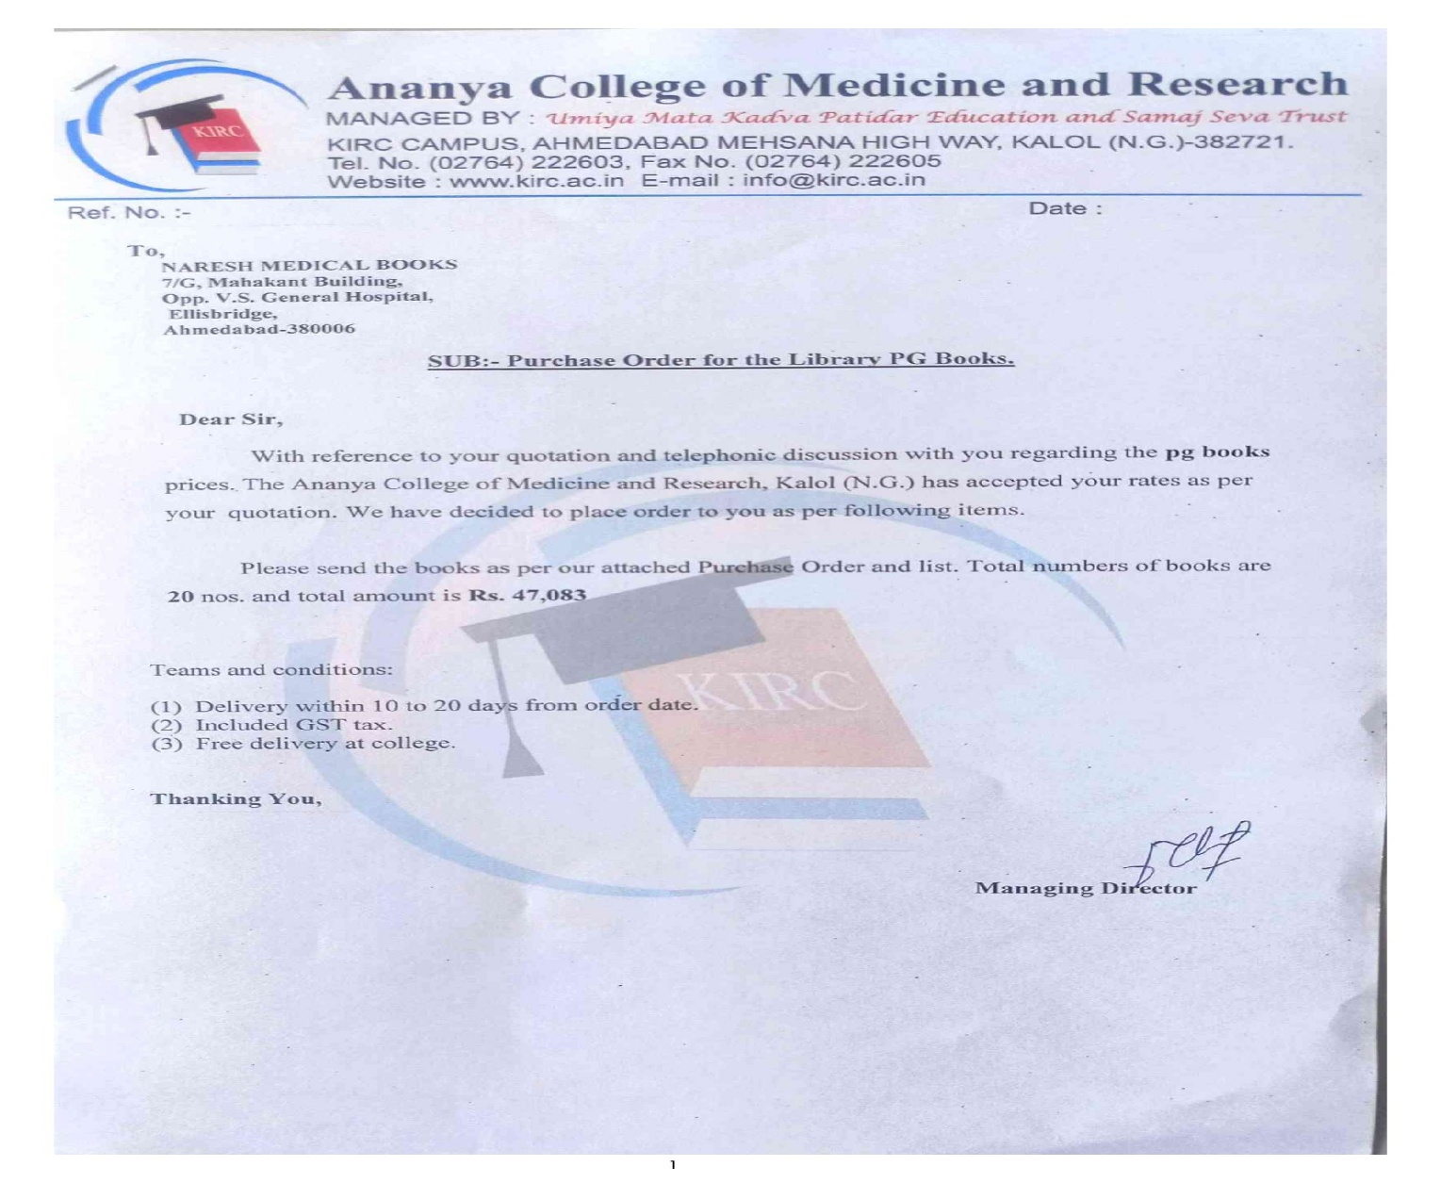

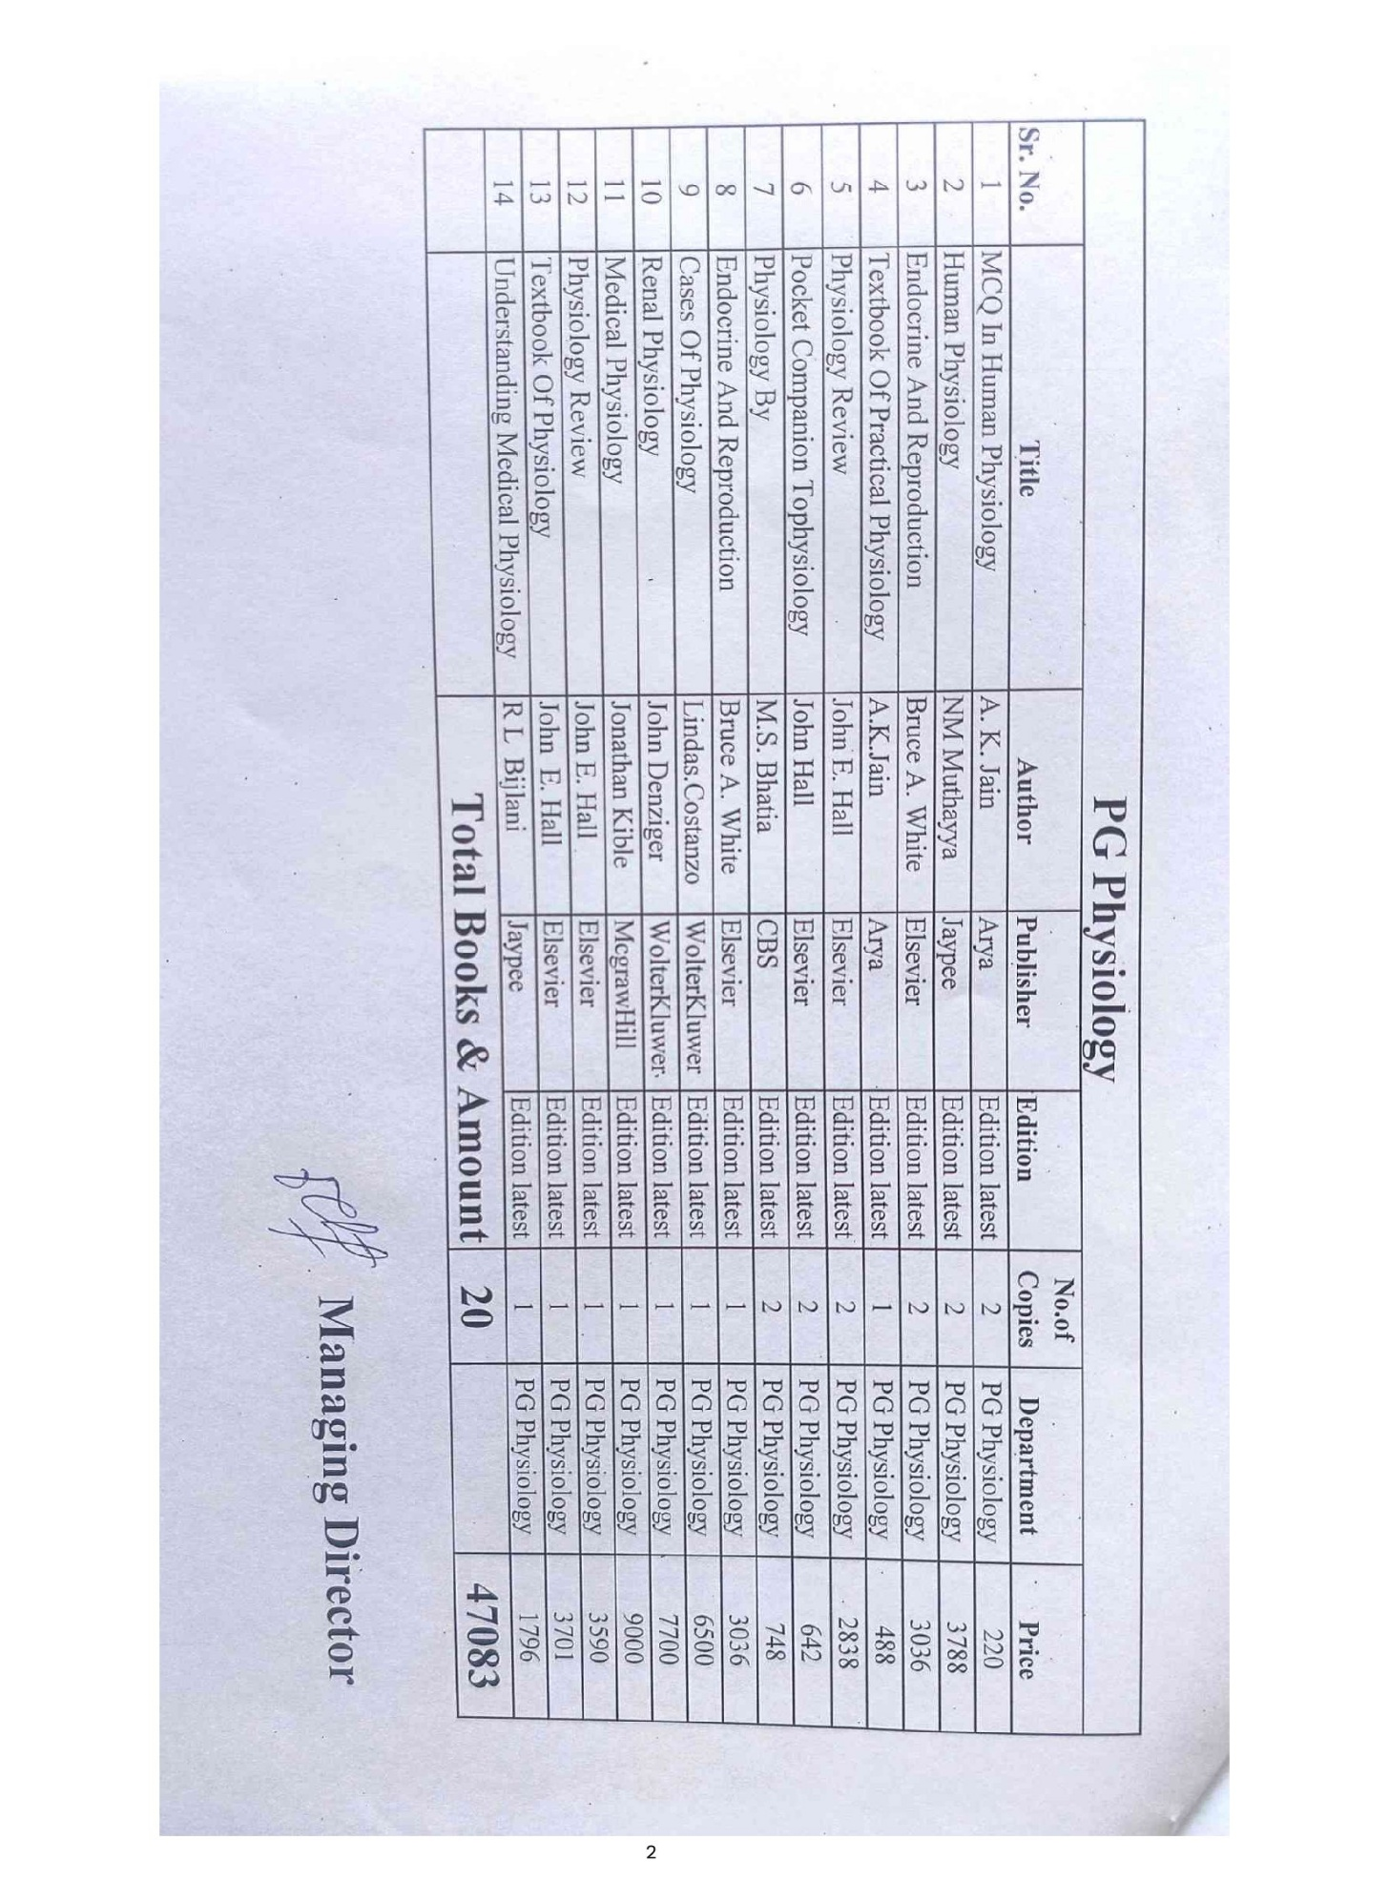

**Physiology journal and ejournals**

**Physiology Journals BOTH: National and international & online offline combined**

|  |  |  |  |  |
| --- | --- | --- | --- | --- |
|  | **Journal Name** | **PISSN** | **EISSN** | **Year** |
| **1** | **Indian Journal of Physiology and Pharmacology** | **0019-5499** | **2882-2799** | **Jan-Dec- 2025** |
| **2** | **International Journal of Physiology** | **2320-6039** | **2320-608X** | **Jan-Dec- 2025** |
| **3** | Advance/s in Physiology Education | 1043-4046 | 1522-1229 | Jan-Dec- 2025 |
| **4** | Development | 0950-1991 | 1477-9129 | Jan-Dec- 2025 |
| **5** | Journal of Physiology and Pharmacology | 0867-5910 | 1899-1505 | Jan-Dec- 2025 |
| **6** | Journal of Cellular and Molecular Medicine | 1582-1838 | 1582-4934 | Jan-Dec- 2025 |
| **7** | Journal of Integrative Neuroscience | 0219-6352 | 1757-448X | Jan-Dec- 2025 |
| **8** | Journal of Physiological Sciences |  | 1880-6562 | Jan-Dec- 2025 |
| **9** | Physiological Research | 0862-8408 | 1802-9973 | Jan-Dec- 2025 |
| **10** | Clinical and Applied Thrombosis/Hemostasis | 1076-0296 | 1938-2723 | Jan-Dec- 2025 |
| **11** | Iranian Biomedical Journal |  | 2980-7824 | Jan-Dec- 2025 |
| **12** | Journal of Human Kinetics | 1640-5544 | 1899-7562 | Jan-Dec- 2025 |
| **13** | Molecular Pain |  | 1744-8069 | Jan-Dec- 2025 |
| **14** | Breathe | 1810-6838 | 2073-4735 | Jan-Dec- 2025 |
| **15** | In Vivo: International Journal of Experimental and Clinical Pathophysiology | 0258-851X | 1791-7549 | Jan-Dec- 2025 |
| **16** | Korean Journal of Physiology and Pharmacology | 1226-4512 | 2093-3827 | Jan-Dec- 2025 |
| **17** | Baltic Journal of Health and Physical Activity | 2080-1297 | 2080-9999 | Jan-Dec- 2025 |
| **18** | Frontiers in Physiology |  | 1664-042X | Jan-Dec- 2025 |
| **19** | Skeletal Muscle | 2044-5040 | 2044-5040 | Jan-Dec- 2025 |
| **20** | Physiology and Pharmacology | 2476-5236 | 2476-5244 | Jan-Dec- 2025 |
| **21** | Conservation Physiology |  | 2051-1434 | Jan-Dec- 2025 |
| **22** | Physiological Reports |  | 2051-817X | Jan-Dec- 2025 |
| **23** | Laboratory Animal Research | 1738-6055 | 2233-7660 | Jan-Dec- 2025 |
| **24** | Journal of Functional Morphology and Kinesiology |  | 2411-5142 | Jan-Dec- 2025 |
| **25** | Archives of Physiotherapy |  | 2057-0082 | Jan-Dec- 2025 |
| **26** | Frontiers in Rehabilitation Sciences |  | 2673-6861 | Jan-Dec- 2025 |
| **27** | Physiologia |  | 2673-9488 | Jan-Dec- 2025 |
| **28** | Frontiers in Network Physiology |  | 2674-0109 | Jan-Dec- 2025 |
| **29** | Health Psychology Research |  | 2420-8124 | Jan-Dec- 2025 |
| **30** | BMC Physiology |  | 1472-6793 | Jan-Dec- 2025 |
| **31** | Indian Pacing and Electrophysiology Journal | 0972-6292 | 0972-6292 | Jan-Dec- 2025 |
| **32** | Journal of Exercise Physiology |  | 1097-9751 | Jan-Dec- 2025 |
| **33** | International Journal of Physiology, Pathophysiology and Pharmacology |  | 1944-8171 | Jan-Dec- 2025 |
| **34** | International Journal of Kinesiology and Sports Science |  | 2202-946X | Jan-Dec- 2025 |
| **35** | International Biomechanics |  | 2333-5432 | Jan-Dec- 2025 |
| **36** | Japanese Journal of Health Physics | 0367-6110 | 1884-7560 | Jan-Dec- 2025 |
| **37** | Journal of In0vations in Cardiac Rhythm Management | 2156-3977 | 2156-3993 | Jan-Dec- 2025 |
| **38** | Lung India | 0970-2113 | 0974-598X | Jan-Dec- 2025 |
| **39** | Indian Journal of Respiratory Care | 2277-9019 | 2321-4899 | Jan-Dec- 2025 |
| **40** | Indian Journal of Science and Tech0logy | 0974-6846 | 0974-5645 | Jan-Dec- 2025 |
| **41** | National Journal of Physiology, Pharmacy and Pharmacology | 2320-4672 | 2231-3206 | Jan-Dec- 2025 |
|  |  |  |  |  |
|  |  |  |  |  |
|  | **Physiology Journal** | |  |  |
|  | **International** | **36** |  |  |
|  | **National** | **5** |  |  |
|  | **Total** | **41** |  |  |

**Annexure E**

**LIST OF INSTRUMENTS IN A RESEARCH LAB**

|  |  |  |
| --- | --- | --- |
| 1 | 3 channel physiograph with PC | 1 |
| 2 | 1 channel physiograph with PC | 2 |
| 3 | HRV Digital physio gram RMS With PC | 1 |
| 4 | Digital spirometer | 1 |
| 5 | Based spirometer | 1 |
| 6 | Manual spirometer | 10 |
| 7 | EEG 32 channel | 1 |
| 8 | EMG RMS | 1 |
| 9 | NMC Aleron 201 | 1 |
| 10 | ANS testing Canwin GENESIS | 1 |
| 11 | BMR (Inco brand) | 1 |
| 12 | Hand grip dynamometer | 2 |
| 13 | Peak flow meter (JK) | 1 |
| 14 | Tilting table for ANS (INCO) | 1 |
| 15 | Erograph | 9 |
| 16 | Stethograph | 6 |
| 17 | Kymograph | 1 |
| 18 | Marry’ tambour | 1 |

**Annexure F**

**Research project done and published**

|  |  |  |  |  |
| --- | --- | --- | --- | --- |
| **Sr. No.** | **Title of publication** | **Name of journal in which article published** | **Indexing of journal (specify only those approved by NMC in TEQ)** | **Date of Acceptance / Publication** |
| 1. | Impact of Humidity on heavy duty workers compared to non- heavy duty workers : A study on Peak expiratory flow rate | Indian journal of applied – basic medical sciences | Indexed with index COPERNICUS | July-2024 |
| 2. | A case control study for diagnostic significance of cerebrospinal fluid (CSF) & serum lactate dehydrogenase (LDH) and total creatine kinase (CK) level in meningitis. | Indian journal of applied – basic medical sciences | Indexed with index COPERNICUS | July-2024 |
| 3. | Carbon dioxide levels in the breath of smokers and non smokers : A comparative study | Indian journal of applied – basic medical sciences | Indexed with index COPERNICUS | July-2024 |

|  |  |  |  |  |
| --- | --- | --- | --- | --- |
| **Sr. No.** | **Title of publication** | **Name of journal in which article published** | **Indexing of journal (specify only those approved by NMC in TEQ)** | **Date of Acceptance / Publication** |
| 5 | A comparative study of pulmonary function test results in AC users verses non user | JACC  Clinical electrophysiology | Indexed with SCOPUS | Jan 2025 |
| 6 | From tribes to a cross sectional study comparing adolescence cognitive and emotional growth. | Comprehensive physiology | Indexed with index Pub.Med | Jan 2025 |
|  |  |  |  |  |

**Annexure G**

**Proposed research projects**

**1**

**Plan of research proposal for year 2025-26**

Dept.: Physiology

Name: Dr. Manisha Makwana , Asst. Professor

1. Title of research project: Comparative Study of Heart Rate Variability in Pregnant and Non-Pregnant Women
2. Brief summary of what is to be done:

Heart rate variability (HRV) is a measure of the variation in time between successive heartbeats, reflecting autonomic nervous system (ANS) function. During pregnancy, physiological changes influence the cardiovascular and autonomic systems to support fetal development.

By comparing HRV in pregnant and non-pregnant women, this study aims to understand how pregnancy alters ANS regulation, with implications for maternal and fetal health monitoring.

1. Involvement of student: Planning / Data Collection / Data Analysis / Manuscript preparation: Data collection and manuscript preparation
2. Timeline of initiation and completion of project: As

Initiation – as HRV Machine available

Completion – within 6 months

1. Status of project: Pending

Scientifically/Ethically- Approved / Pending / to be submitted

1. Any source of funding: Yes / No. If yes, specify____-____________
2. Any assistance required from institute: Yes / No. If yes, specify___: Require Heart rate variability software installation in physiograph _
3. Total cost which would be borne by the institute: -

2

**Plan of research proposal for year 2025-26**

Dept.: Physiology

Name: Dr.Darshankumar Patel

1) Title of research project : Autonomic Function Tests in normotensive and hypertensive

patients : A Comparative study

2) Brief summary of what is to be done: Autonomic function tests assess sympathetic and parasympathetic activity in normotensive and hypertensive individuals using methods like heart rate variability, the Valsalva maneuver, orthostatic tests, and the cold pressor test. Participants are categorized based on blood pressure, with confounding factors excluded, and tests are conducted under standardized conditions. Data is recorded using ECG and BP monitors and analyzed statistically to compare autonomic responses between the groups. Hypertensive patients often show reduced parasympathetic activity and exaggerated sympathetic responses compared to normotensive controls

3) Involvement of student: Planning ,Data Collection and Data Analysis 4) Timeline of initiation and completion of project:

· Months 1–2: Recruitment and training of staff. • Months 3–4: Data collection.

• Month 5: Data analysis.

• Month 6: Report writing and dissemination.

5)project status: Scientifically/Ethically- yet to be submitted

6)Any source of funding: No

7)Any assistance required from institute:

-ANS system -1 machine

-Transport facility for subjects to get tested or incentives paid to subjects

8)Total cost which would be borne by the institute: 200000-300000 Rs with machine maintenance

cost.

3

**Plan of research proposal for year 2025-26**

Dept.: Physiology

Name: Dr Sachinkumar Patel

1) Title of research project: Effect of Classical Music on EEG Waves in Volunteers

2) Brief summary of what is to be done: EEG wave analysis to identify changes in

alpha, beta, theta, delta, and gamma bands. Statistical comparison using paired

t-tests or repeated measures ANOVA.

3) Involvement of student: Planning / Data Collection / Data Analysis / Manuscript

preparation

4) Timeline of initiation and completion of project:

Months 1–2: Recruitment and training of staff.

Months 3–4: Data collection.

Month 5: Data analysis.

Month 6: Report writing and dissemination.

Total - 6 Months after initiation

5) Status of project:

Yet to be submitted

6) Any source of funding: ~~Yes~~ / No.

7) Any assistance required from the institute: Yes / ~~No.~~ If yes, specify EEG

recording device (e.g., 32-channel system) And one Desktop Computer and

machine maintenance. Transport facility for volunteers to get tested.

8) Total cost which would be borne by the institute: - Approx 2,50,000/- and EEG

Machine Maintenance Cost. Incentives paid to volunteers.

4

**Plan of research proposal for year 2025-26**

Dept.: Physiology

Name: Dr Janardan Bhatt ,Jayesh shyam, Ankita Bhabhor Raghu Bhammer

1. Title of research project:

Impact Musculo skeletal status on quality of Life of elderly population

A camp-based study

1. Brief summary of what is to be done:

In this project a camp will be organized in nearby elderly houses and single leg standing time and 6 minute walk tests will be applied and correlated with quality of life by simple questionnaire. Correlations will be assessed statistically and data will be published

1. Involvement of student: Planning / Data Collection / Data Analysis / Manuscript preparation
2. Timeline of initiation and completion of project:

Feb 2025 to June 2025

1. Status of project:

Scientifically/Ethically- Approved / Pending / to be submitted

pending

1. Any source of funding: Yes / No. If yes, specify________________

Nil

1. Any assistance required from institute: Yes / No. If yes, specify_______________

Permission for organizing camp in elderly house by students

1. Total cost which would be borne by the institute:

10000 INR to volunteers and elder people as token of gift

**5**

**Plan of research proposal for year 2025-26**

Dept.: Physiology

Name: Nishka ,Dr Janardan Bhatt

1. Title of research project:

Study of prescription writing behavior of multi-vitamin preparations amongst physicians of urban and rural areas of Gujarat

A comparative study

1. Brief summary of what is to be done:

In this project, we will compare the pattern of writing multivitamin drug prescriptions among IMG of rural area of Gandhinagar district and the Urban area of Ahmedabad

The data will compare statistically and the result will be published

1. Involvement of student: Planning / Data Collection / Data Analysis / Manuscript preparation

All level

1. Timeline of initiation and completion of project:

Jan 2025 to June 2025

1. Status of project:

Scientifically/Ethically- Approved / Pending / to be submitted

pending

1. Any source of funding: Yes / No. If yes, specify________________

Nil

1. Any assistance required from institute: Yes / No. If yes, specify_______________

Nil

1. Total cost which would be borne by the institute:

Nil

**6**

**Plan of research proposal for the year 2025-26**

**Dept.: Physiology/MEU**

Name: Jumana Attarwala Dr Janardan Bhatt

1. Title of research project:?

**Do our IMG write prescriptions as per NMC guidelines**

1. Brief summary of what is to be done:

In we will assess the prescriptions written by IMGs at various settings and check whether they are as per guidelines given by National Medical Commission or not

1. Involvement of student: Planning / Data Collection / Data Analysis / Manuscript Preparation

All level

1. Timeline of initiation and completion of project:

Jan 2025 to Fab 2025

1. Status of project:

Scientifically/Ethically- Approved / Pending / to be submitted

pending

1. Any source of funding: Yes / No. If yes, specify________________

No

1. Any assistance required from institute: Yes / No. If yes, specify_______________

No

1. Total cost which would be borne by the institute:

Nil

**Annexure H**

**List of seminars………..**

|  |  |  |  |  |  |
| --- | --- | --- | --- | --- | --- |
| 2024-11-01 00:00:00 | Friday | November | 2024 | SEMINAR | [BRAINSTORMING](https://dovetail.com/ux/brainstorming/) |
| 2024-11-02 00:00:00 | Saturday | November | 2024 | - | GOVARDHAN PUJA- HOLIDAY |
| 2024-11-03 00:00:00 | Sunday | November | 2024 | - | SUNDAY |
| 2024-11-04 00:00:00 | Monday | November | 2024 | GROUP DISCUSSION | VACCINATIONS 2025 |
| 2024-11-05 00:00:00 | Tuesday | November | 2024 | GUEST LECTURE | MRNA VACCINES FOR VIRAL INFECTIONS |
| 2024-11-06 00:00:00 | Wednesday | November | 2024 | CME | DATA ANALYSIS |
| 2024-11-07 00:00:00 | Thursday | November | 2024 | SYMPOSIUM | ARTIFICIAL TISSUES FABRICATION |
| 2024-11-08 00:00:00 | Friday | November | 2024 | SEMINAR | MEDICAL RESEARCH TOPICS FOR MEDICAL STUDENTS |
| 2024-11-09 00:00:00 | Saturday | November | 2024 | JOURNAL CLUB | BY DR. JANARDAN BHATT SIR |
| 2024-11-10 00:00:00 | Sunday | November | 2024 | - | SUNDAY |
| 2024-11-11 00:00:00 | Monday | November | 2024 | GROUP DISCUSSION | MELATONIN. |
| 2024-11-12 00:00:00 | Tuesday | November | 2024 | GUEST LECTURE | ALZHEIMER’S AND DEMENTIA |
| 2024-11-13 00:00:00 | Wednesday | November | 2024 | CME | COGNITIVE FUNCTION TEST |
| 2024-11-14 00:00:00 | Thursday | November | 2024 | SYMPOSIUM | SYMPTOMS OF DEMENTIA |
| 2024-11-15 00:00:00 | Friday | November | 2024 | SEMINAR | LIFESTYLE HABITS AND PUBLIC HEALTH |
| 2024-11-16 00:00:00 | Saturday | November | 2024 | JOURNAL CLUB | BY DR. MANISHA MAKWANA |
| 2024-11-17 00:00:00 | Sunday | November | 2024 | - | SUNDAY |
| 2024-11-18 00:00:00 | Monday | November | 2024 | GROUP DISCUSSION | THE RISE OF UPPER BACK AND NECK PAIN FROM LAPTOP |
| 2024-11-19 00:00:00 | Tuesday | November | 2024 | GUEST LECTURE | REPETITIVE STRAIN INJURIES (RSI) |
| 2024-11-20 00:00:00 | Wednesday | November | 2024 | CME | ATTENTION-AND CONCENTRATION |
| 2024-11-21 00:00:00 | Thursday | November | 2024 | SYMPOSIUM | MEDITATION |
| 2024-11-22 00:00:00 | Friday | November | 2024 | SEMINAR | MEDICAL USES AND MECHANISMS OF CANNABIS |
| 2024-11-23 00:00:00 | Saturday | November | 2024 | JOURNAL CLUB | BY DR. DARSHAN PATEL |
| 2024-11-24 00:00:00 | Sunday | November | 2024 | - | SUNDAY |
| 2024-11-25 00:00:00 | Monday | November | 2024 | GROUP DISCUSSION | CBD’S IMPACT ON CHRONIC PAIN |
| 2024-11-26 00:00:00 | Tuesday | November | 2024 | GUEST LECTURE | HUMAN GENETICS |
| 2024-11-27 00:00:00 | Wednesday | November | 2024 | CME | GENOME PROJECT |
| 2024-11-28 00:00:00 | Thursday | November | 2024 | SYMPOSIUM | DNA |
| 2024-11-29 00:00:00 | Friday | November | 2024 | SEMINAR | GENETIC-BASED HEALTH DISORDERS |
| 2024-11-30 00:00:00 | Saturday | November | 2024 | JOURNAL CLUB | BY DR.SACHIN PATEL |
| 2024-12-01 00:00:00 | Sunday | December | 2024 | - | SUNDAY |
| 2024-12-02 00:00:00 | Monday | December | 2024 | GROUP DISCUSSION | MACHINE LEARNING |
| 2024-12-03 00:00:00 | Tuesday | December | 2024 | GUEST LECTURE | SEXUAL HEALTH STUDIES |
| 2024-12-04 00:00:00 | Wednesday | December | 2024 | CME | LGBTQIA+ COMMUNITY |
| 2024-12-05 00:00:00 | Thursday | December | 2024 | SYMPOSIUM | SEXUALLY TRANSMITTED INFECTIONS |
| 2024-12-06 00:00:00 | Friday | December | 2024 | SEMINAR | SAFE SEX RESOURCES |
| 2024-12-07 00:00:00 | Saturday | December | 2024 | JOURNAL CLUB | BY DR. JANARDAN BHATT SIR |
| 2024-12-08 00:00:00 | Sunday | December | 2024 | - | SUNDAY |
| 2024-12-09 00:00:00 | Monday | December | 2024 | GROUP DISCUSSION | HEALTHIER LIFESTYLES SCALES |
| 2024-12-10 00:00:00 | Tuesday | December | 2024 | GUEST LECTURE | WELLNESS INDEX |
| 2024-12-11 00:00:00 | Wednesday | December | 2024 | CME | SPACE PHYSIOLOGY |
| 2024-12-12 00:00:00 | Thursday | December | 2024 | SYMPOSIUM | GLUTEN SENSITIVITY ALLERGIES |
| 2024-12-13 00:00:00 | Friday | December | 2024 | SEMINAR | GASTROINTESTINAL SYMPTOMS |
| 2024-12-14 00:00:00 | Saturday | December | 2024 | JOURNAL CLUB | BY DR. MANISHA MAKWANA |
| 2024-12-15 00:00:00 | Sunday | December | 2024 | - | SUNDAY |
| 2024-12-16 00:00:00 | Monday | December | 2024 | GROUP DISCUSSION | URBAN CITIES & POLLUTANTS. |
| 2024-12-17 00:00:00 | Tuesday | December | 2024 | GUEST LECTURE | IMMUNE BASIS OF ASTHMA |
| 2024-12-18 00:00:00 | Wednesday | December | 2024 | CME | PFT |
| 2024-12-19 00:00:00 | Thursday | December | 2024 | SYMPOSIUM | STEROID THERAPY |
| 2024-12-20 00:00:00 | Friday | December | 2024 | SEMINAR | GEO MEDICINE |
| 2024-12-21 00:00:00 | Saturday | December | 2024 | JOURNAL CLUB | BY DR.DARSHAN PATEL |
| 2024-12-22 00:00:00 | Sunday | December | 2024 | - | SUNDAY |
| 2024-12-23 00:00:00 | Monday | December | 2024 | GROUP DISCUSSION | PLANT-BASED DIETS |
| 2024-12-24 00:00:00 | Tuesday | December | 2024 | GUEST LECTURE | HOLISTIC HEALTH |
| 2024-12-25 00:00:00 | Wednesday | December | 2024 | - | CHRISTMUS - HOLIDAY |
| 2024-12-26 00:00:00 | Thursday | December | 2024 | CME | DIET AND LIFESTYLE |
| 2024-12-27 00:00:00 | Friday | December | 2024 | SYMPOSIUM | HEALTH SUPPLEMENTS |
| 2024-12-28 00:00:00 | Saturday | December | 2024 | SEMINAR | OMEGA-3 FISH OIL SAFETY AND EFFICACY |
| 2024-12-29 00:00:00 | Sunday | December | 2024 | - | SUNDAY |
| 2024-12-30 00:00:00 | Monday | December | 2024 | JOURNAL CLUB | BY DR. SACHIN PATEL |
| 2024-12-31 00:00:00 | Tuesday | December | 2024 | GROUP DISCUSSION | INSTITUTIONAL REVIEW BOARD (IRB). AND NABH |
| 2025-01-01 00:00:00 | Wednesday | January | 2025 | GUEST LECTURE | THE PROS AND CONS OF ELECTRONIC HEALTH RECORDS |
| 2025-01-02 00:00:00 | Thursday | January | 2025 | CME | MEDICAL APP |
| 2025-01-03 00:00:00 | Friday | January | 2025 | SYMPOSIUM | HEALTH APPS |
| 2025-01-04 00:00:00 | Saturday | January | 2025 | SEMINAR | MEDICATION ERRORS |
| 2025-01-05 00:00:00 | Sunday | January | 2025 | - | SUNDAY |
| 2025-01-06 00:00:00 | Monday | January | 2025 | JOURNAL CLUB | BY DR. JANARDAN BHATT SIR |
| 2025-01-07 00:00:00 | Tuesday | January | 2025 | GROUP DISCUSSION | NEW METHOD OF STAGING CANCER STAGE |
| 2025-01-08 00:00:00 | Wednesday | January | 2025 | GUEST LECTURE | NEWER METHOD OF DIAGNOSIS OF CANCER |
| 2025-01-09 00:00:00 | Thursday | January | 2025 | CME | IMMUNITY AND CANCERS |
| 2025-01-10 00:00:00 | Friday | January | 2025 | SYMPOSIUM | DIAGNOSTIC AND TREATMENT RATES ACROSS ETHNICITIES |
| 2025-01-11 00:00:00 | Saturday | January | 2025 | SEMINAR | THE PREVALENCE OF DIABETES IN INDIGENOUS COMMUNITIES |
| 2025-01-12 00:00:00 | Sunday | January | 2025 | - | SUNDAY |
| 2025-01-13 00:00:00 | Monday | January | 2025 | JOURNAL CLUB | BY DR. MANISHA MAKWANA |
| 2025-01-14 00:00:00 | Tuesday | January | 2025 | - | UTTARAYAN - HOLIDAY |
| 2025-01-15 00:00:00 | Wednesday | January | 2025 | - | POST UTTARAYAN |
| 2025-01-16 00:00:00 | Thursday | January | 2025 | GROUP DISCUSSION | ONCOGENIC GENE |
| 2025-01-17 00:00:00 | Friday | January | 2025 | GUEST LECTURE | DYSREGULATION OF GENES |
| 2025-01-18 00:00:00 | Saturday | January | 2025 | CME | PAIN PHYSIOLOGY |
| 2025-01-19 00:00:00 | Sunday | January | 2025 | - | SUNDAY |
| 2025-01-20 00:00:00 | Monday | January | 2025 | SYMPOSIUM | CANCER VACCINES AND TARGETED THERAPIES |
| 2025-01-21 00:00:00 | Tuesday | January | 2025 | SEMINAR | IMMUNOTHERAPY FOR CANCER |
| 2025-01-22 00:00:00 | Wednesday | January | 2025 | JOURNAL CLUB | BY DR.DARSHAN PATEL |
| 2025-01-23 00:00:00 | Thursday | January | 2025 | GROUP DISCUSSION | ALTERNATIVES OF PAIN THERAPY |
| 2025-01-24 00:00:00 | Friday | January | 2025 | GUEST LECTURE | ACCUPUNCURE |
| 2025-01-25 00:00:00 | Saturday | January | 2025 | CME | OPIUODS |
| 2025-01-26 00:00:00 | Sunday | January | 2025 | - | SUNDAY |
| 2025-01-27 00:00:00 | Monday | January | 2025 | SYMPOSIUM | ANTI-INFLAMMATORY MEDICATIONS FOR PAIN CONTROL |
| 2025-01-28 00:00:00 | Tuesday | January | 2025 | SEMINAR | [DATA COLLECTION](https://dovetail.com/research/data-collection/) |
| 2025-01-29 00:00:00 | Wednesday | January | 2025 | JOURNAL CLUB | BY DR.SACHIN PATEL |
| 2025-01-30 00:00:00 | Thursday | January | 2025 | GROUP DISCUSSION | FUTURE OF HEALTHCARE. |
| 2025-01-31 00:00:00 | Friday | January | 2025 | GUEST LECTURE | ROBOTICS in Medical sciences |
| 2025-02-01 00:00:00 | Saturday | February | 2025 | CME | NEURAL NETWORKS |
| 2025-02-02 00:00:00 | Sunday | February | 2025 | - | SUNDAY |